**and Thistle**



**The Sword**

**February 2026**

**Gàidheil gu bràth – Highlanders Forever!**

*A newsletter for the members of the 79th New York Highlanders*

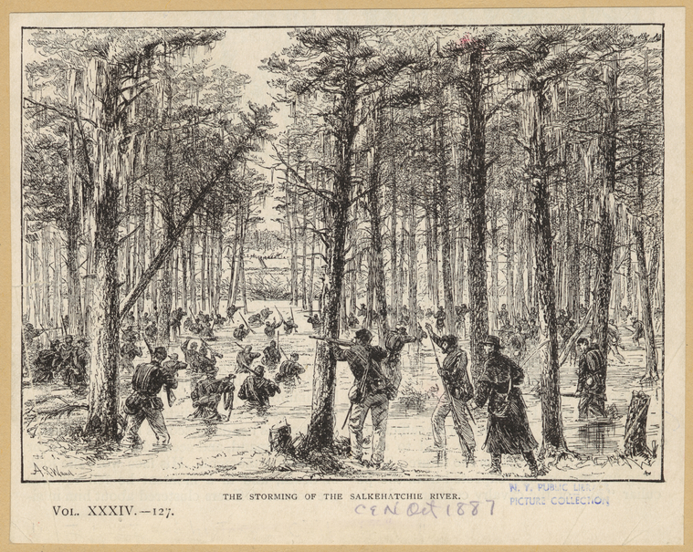

*The Storming of the Salkehatchie River, Battle of Rivers Bridge South Carolina February 3, 1865. This occurred one day after the action at Broxton Bridge on February 2, 1865 in similar conditions.*

**Mark Your Calendars 2026 First Event:**

**Broxton Bridge – February 27 – March 1**

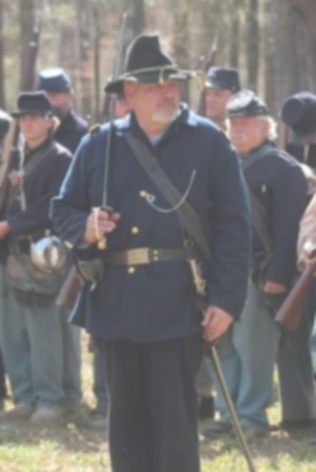**From The Editor:**

*Capt. Tom Vaselopulos*

Greetings Highlanders, and welcome to the early February edition of *The Sword and Thistle*. With our first reenacting event coming up at the end of month it is important that we get information to you as soon as possible.

**BROXTON BRIDGE** February 27th to March 1st, 2026. I do not know about the rest of the company, but I get excited just thinking about it. One of the best events that our company will do each year and one that most everyone agrees is a well-run and exciting event to start the year off. It is also an event where the organizers take great care of all reenactors and provide all who participate a dinner and rations.

As reenactors being able to portray these brave men on an actual battle site is something extremely important, and I for one get a chill just walking through the breastworks and thinking about those who fought and died for the causes that they believed in and we as reenactors get to honor them by recreating the event for those that attend the event. Looking at the cover page, you can only imagine the difficulty of wading through the cold swamp to attack the rebel positions. It makes you really appreciate the actions of those men.

That is why it is important for us to know the history of the event to be able to answer any questions that visitors may have. So please go to page five of this newsletter and read about the history of the campaign and battle.

If you have not registered for the event, please do so as soon as possible. Remember this is a Maximum Effort for the company to make. I am looking forward to seeing all of you there and once again be with my reenacting family.

*Gàidheil gu bràth – Highlanders Forever!*



**The Commanders Corner**

*By Col. Bob Dotson*

I am looking forward to seeing each of you at this year's Battle of Broxton Bridge Reenactment. As I peer through my window and gaze upon the frozen wilderness of Northeast Tennessee, my desire to join my pards around a roaring campfire significantly intensifies! Below, I have provided a brief synopsis on the battle. I truly hope that you find it valuable and that it will increase your desire to join me at that fire. --*The Colonel.*

February 1–3, 1865, witnessed the Battles of Broxton and Rivers Bridge. These strategic battles were designed to remove Confederate defenses against Gen. William T. Sherman’s campaign north through the interior of South Carolina. The bridges were the last major points of resistance in the region and controlled access across the swamps of the Salkehatchie River. The removal of the Confederate forces at these crossings would open the way for Sherman’s advance.

This engagement would prove difficult for the advancing Federal forces. Confederates, with only 1200 men, had utilized the flooded Salkehatchie River swamps to aid in defending against the far superior force of 7,000 Union troops. The ultimate Union victory allowed their forces to advance to Orangeburg, but not without a price. After the Battle of Rivers Bridge, Lt. Col. Oscar L. Jackson with the 63rd Ohio Infantry, wrote the following:

 --*Again, at the hospital I see the horrid results of every battle. Men mutilated in every shape conceivable, groaning, begging for assistance and gasping in death. Many of our wounded will have to lie all night in that horrid swamp, it being impossible to find them and carry them out on the narrow foot bridge that has been made. Many have had their heads propped up out of the water where they lay to keep them from drowning--*

*Lt. Col. Oscar L. Jackson*



**Upcoming Highlander Events**

* Broxton Bridge – February 27 – March 1 – *kickoff event*
* WFB COI (Richmond KY) March 20th – 22nd *(pick up event)*
* Resaca – May 15th – 17th - *to be voted on.*
* Battle of Franklin, October 2- 4th, Lebanon TN – *to be voted on*
* Beaufort – November 7th Living History



**Highlander History for February:**

* **February 1862 –** Continued operations in Beaufort SC.
* **February 17th, 1863** - Colonel Farnsworth was discharged for disability from his Second Bull Run wound. Lieutenant Colonel David Morrison was promoted to colonel.
* **February 1864** – Continued operations in Eastern Tennessee



***“War is cruelty. There is no use trying to reform it. The crueler it is the sooner it will be over.”***

***Gen. William Tecumseh Sherman***

**Information About the Broxton Bridge Event**

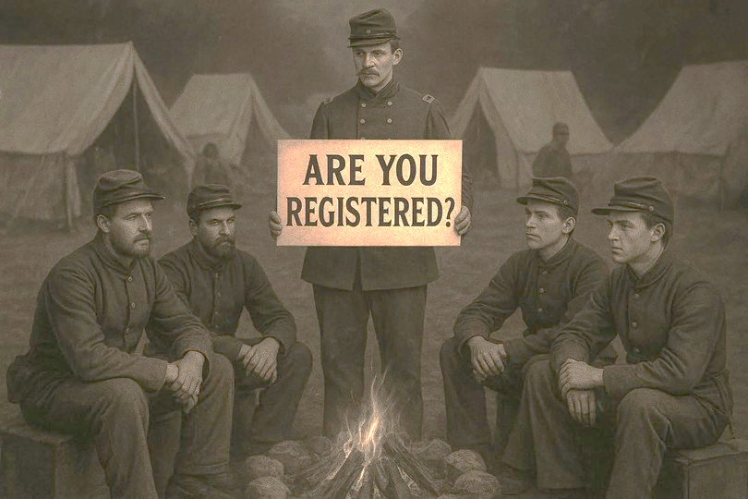

For all those going to Broxton Bridge reenactment please go to the following Web site for valuable information about the event:

[Reenactment | Broxton Bridge](https://www.broxtonbridge.com/reenactment)

Some key points that are important to know:

* Living History Day for schoolchildren to tour is Friday, February 27th, 2026, beginning at 9am​. ​
* The battle reenactments will begin at 2:00 pm on Saturday Feb. 28th and Sunday Mar. 1st.
* Camps are open Saturday February 28th 9:00 am - 5:00 pm and Sunday Mar. 1st 9:00 am - 4:00 pm
* For Reenactors there will be a $15.00 registration fee for participants aged 18+ and $7 for ages 10-17
* Dinner (Friday evening) and rations will be available again for participants.



**Articles and Readers Wanted:**

*The Sword and Thistle* is the Company Newsletter of H Company, 79th New York Highlanders.

The information in the newsletter is to provide items of interest to our members and to help improve their impressions in the field. ***Therefore, we need readers, and we need those readers to help provide articles that will help all of us.***

Articles should be of general interest to battles, uniforms and equipment, food, and the life of the soldiers. Please submit your articles to the editor by the 10th of each month with the newsletter to be published by the 15th. The editor reserves the right to edit for space and content.

Thank you for your support.

**February Civil War Battle of Interests – Aiken and Broxton Bridge, SC**

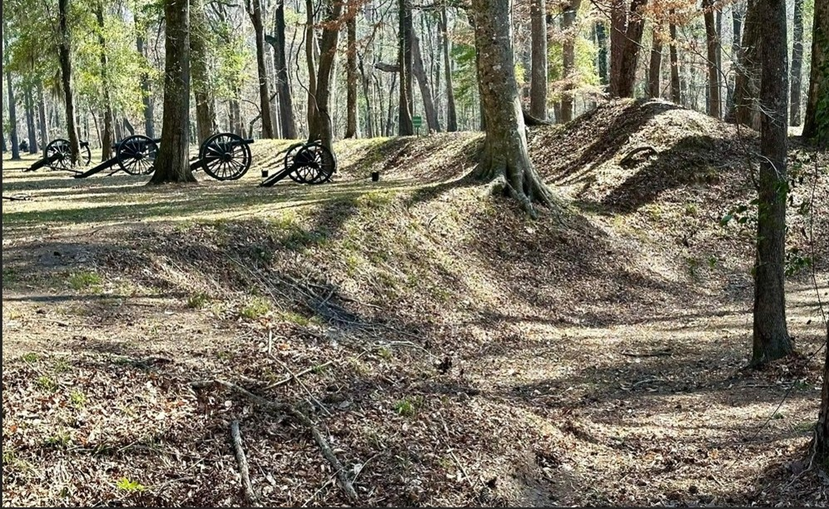

The **Battle of Broxton Bridge** took place during February 2, 1865, and coincided with the Battle of Rivers Bridge along the Salkehatchie River in Bamberg County, South Carolina. The battle concluded in a Union victory and resulted in the destruction of the last Confederate defensive line before the Union Army went on to capture Columbia later that month.

**Pre-Battle Situation**

The Union Army took part in the Carolinas campaign by departing Savannah for Columbia, SC on February 1, 1865. The Confederate Army attempted to halt the Union Army's advance by setting up several defensive positions along the Salkehatchie River such as Rivers Bridge, Buford's Bridge, and Broxton's Bridge.

**The Battle**

When the Union Army under the command of Major General William Sherman reached the Confederate defenses on February 2, Sherman decided to send his left wing, consisting of the Army's First Division under the command of Major General Joseph Mower to march on Broxton Bridge while the rest of the XVII would attempt to capture Rivers' Bridge which lay upstream. The Salkehatchie River was the final defense line before the Union Army could march on Columbia, so the capture of at least one crossing proved crucial if the campaign were to succeed.

The first skirmish of the battle occurred between a Union infantry battalion of the First Division and the Confederate Cavalry, in which the Union forces proved victorious as the Confederate Cavalry retreated behind Broxton Bridge. Seeing this retreat Major General Mower ordered an attack on Broxton Bridge but was repelled by the Confederates. Following this loss, Mower ordered his troops to instead march six miles upstream to assist his comrades in the Battle of Rivers' Bridge.

As a full-frontal charge was deemed impossible due to the Confederates strongly entrenched positions, an attack was delayed until the next day when the Union forces crossed the Rivers' Bridge by plowing through a nearby swamp. At the same time a small Union force had returned to Broxton Bridge to engage the enemy again in a flanking maneuver. This time the attack proved successful, and as a result forced the Confederate Army to abandon their positions and retreat toward Columbia.

**Aftermath**

The Union victories at Broxton Bridge and Rivers' Bridge led to the occupation of the countryside North of the Salkehatchie River by the Union Army, as well as the ability to cut off the South Carolina Railroad, an important supply line, from the Confederate defenders. The defeat of the Confederate Army at Salkehatchie River also ultimately led to the capture of Columbia later that month. The Union casualties were recovered shortly after the battle and were buried in the National Cemetery at Beaufort, SC.

Battle casualties for the Union Army 16 killed and eighty-five wounded. Confederate casualties were reported as eight killed, forty-five wounded and forty-four captured.

Currently, the Broxton Bridge location still bears the scars of the battle that took place in 1865. Some breastworks are still well preserved as well as remnants of the Confederate defense lines. A re-enactment of the battle takes place yearly near the old battlefield.

**The Battle of Aiken, SC**

*“The Battle of Aiken” is a 22-page booklet first published in 1964 for the Centennial celebration of the battle in February 1965. Written by Raymond Boylston, Jr.*

The **Battle of Aiken** occurred on February 11, 1865, and was part of the Carolinas Campaign. The principal commanders were Union Maj. Gen. Hugh Judson Kilpatrick and Confederate Maj. Gen. Joseph Wheeler. Wheeler was able to score a minor victory over Kilpatrick.

Before the battle, on February 1, General Sherman began his invasion of South Carolina. During the campaign he ordered Hugh Judson Kilpatrick and his cavalry corps from the Fifth Cavalry to march through South Carolina. By February 5, he crossed into Aiken County (*this is incorrect as Aiken County was not organized until 1871 from portions of Barnwell, Edgefield, Lexington and Orangeburg counties*) where he would engage in battle with Wheeler’s cavalry corps. Wheeler attacked Kilpatrick, who expected little resistance, despite having orders to not pursue Kilpatrick's cavalry. Wheeler moved to defend the city of Augusta from the Union Army. His army was stationed at 204 Park Avenue between Benjamin Cheatham and James Smith’s forces. The Aiken Home Guard and a cavalry corps were under Wheeler's command. He planned to defeat Kilpatrick by forming his cavalry into a V-shaped formation with skirmishers deployed above it. When Kilpatrick charged the skirmishers, they would retreat into the center of the "V." Once Kilpatrick entered the formation the tips of the "V" would collapse, thus encircling Kilpatrick. On February 11, at 9:00 AM, the battle started.

Wheeler's plan was prevented from coming to fruition due to a single Confederate soldier who prematurely fired their gun resulting in Wheeler ordering all his soldiers to attack the Union forces. The armies engaged in hand-to-hand combat throughout the town. During the fighting, it was reported that a Confederate soldier ran up to Kilpatrick and attacked the general with his pistol. However, the pistol did not fire. After Kilpatrick was defeated, he retreated to his defenses at Montmorenci. For the rest of the day, Confederate and Union soldiers skirmished. This continued until the two commanders signed a truce and agreed to collect the bodies. Later, on February 13, Kilpatrick retreated and rejoined Sherman. Despite this, Kilpatrick declared himself victorious. In the aftermath of the battle, Wheeler's decision to attack Kilpatrick left the Edisto River and in turn Columbia, vulnerable.

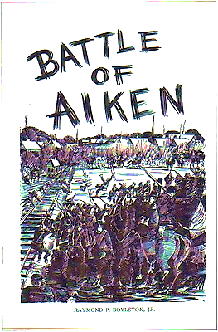

*The Battle of Aiken drawing from the booklet by Boylston*

**Casualties**

According to General Kilpatrick, he had killed 31 Confederate soldiers, wounded 160, and captured sixty. This would result in the Confederate casualties of 251. However general Wheeler states that he had suffered only fifty casualties and that he had killed 53 Union soldiers, wounded 270, and captured 172. This totaled 495 Union Casualties. *(Editor’s note – both Generals were known for their wild exaggerations regarding casualties their own and their opponents).*

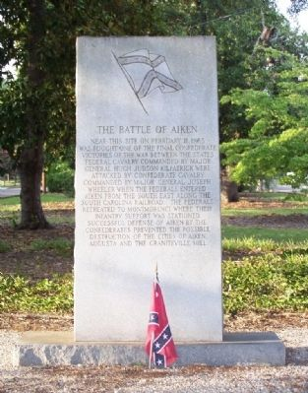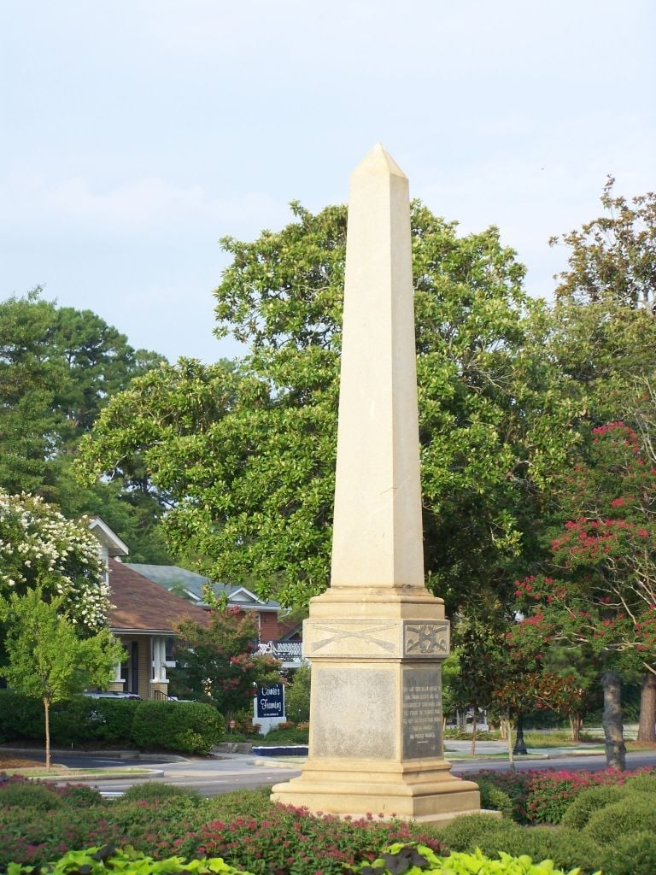To commemorate the battle, a granite monument was erected at the intersection of Richland Avenue and Chesterfield Street, photo on the far left.

The battle marker is on Chesterfield Street NE near Richland Avenue (U.S. 78), in the median, photo to the left.

The graves for twenty Union soldiers can be found on the property of the First Baptist Church, close to the battle marker. They lie mostly forgotten.

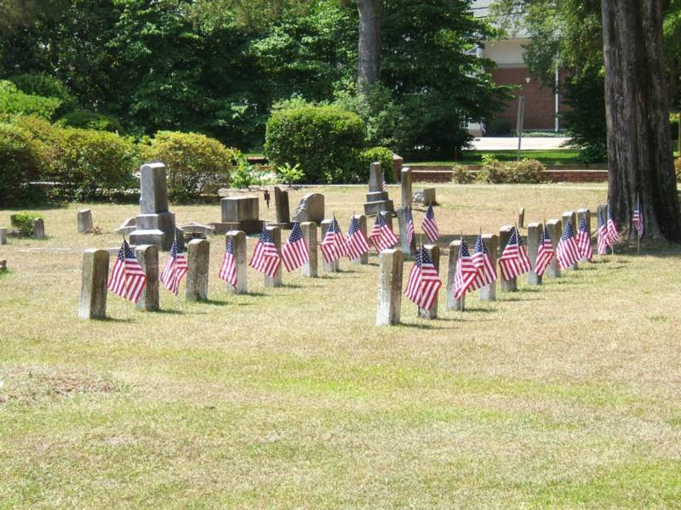



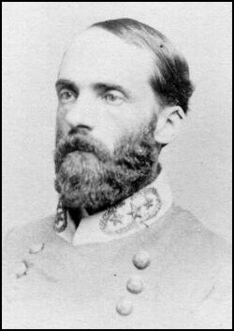**General Wheeler Carolinias Campaign criticized**

General Joseph "Fighting Joe" Wheeler faced significant criticism during the Carolinas Campaign and the preceding March to the Sea, primarily focusing on the indiscipline of his cavalry, their failure to stop Union forces, and his alleged shortcomings as a high-level commander. While recognized for his bravery and tireless activity, his command was often accused of behaving as poorly as Union "bummers" in their treatment of Southern civilians. An investigation ordered by P.G.T. Beauregard in early 1865 found that, while some accusations of misconduct were exaggerated, many were accurate. Wheeler was replaced as cavalry chief by Lt. Gen. Wade Hampton III, and he fought under him later at the Battle of Bentonville.

**From the Chaplain**

*By Chaplain Fred London and Tom Vaselopulos*

On August 3, 1861, the United States Congress set the guidelines for Union chaplains. They were to be elected by the ranks and commissioned as officers by the regimental colonel commanding, after which the chaplain’s name was to be forwarded to the War Department for commissioning. The term of service for a chaplain ranged from three months to nine months, or even three years, depending on the terms of enlistment for the regiment.

Once commissioned, a Union chaplain was to receive $100 per month, plus rations, and feed for one horse, if they had one. According to General Order 102, they were to wear a plain black frock coat with one row of nine black buttons, plain black trousers, and a plain dark blue forage cap. In many cases chaplains would wear civilian clothing and hats.

Army regimental chaplains were required to report quarterly to the regimental commander on the units “moral and religious condition” and ways to make any improvements.

All told, at least 2387 men and one woman served in the Union army as Chaplains, with sixty-six dying in service and three earning the Medal of Honor.

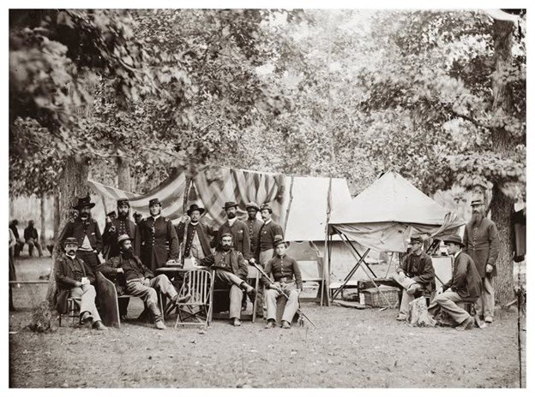

*Their chaplain who is standing fifth from the left is not wearing the regulation frock, but a civilian coat as was often the case.*

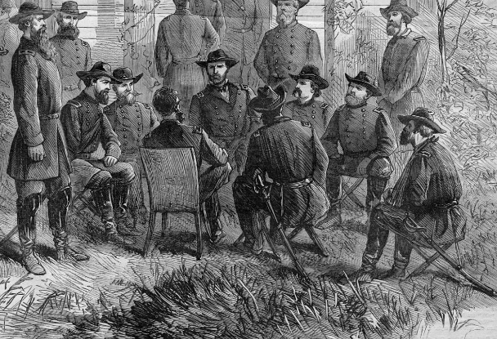**Civil War Slang – V - Z**

**V**

**430. Veal:** Raw recruits

**431. Vidette:** a sentry same as Picket but usually on horseback

**432. Virginia fence:** A staggering drunk was said to make this zig-zagging motion when he walked. Also, it meant anyone or anything that meanders. anything that meanders.

**433. Vittles:** Food

**W**

**434. Wake snakes:** To raise a ruckus.

**435. Wag:** Joker

**436. Wallpapered:** drunk

**437. Web Feet:** Term cavalry had for infantry

**438. What the dickens:** mild exclamation "what the devil."

**439. Whip one's weight in wild cats:** To defeat a powerful opponent

**440. Whipped:** beaten

**441. Whitewash:** To gloss over or hide one's faults or shortcomings

**442. Widder:** Widow

**443. Worm castles:** Hardtack

**444. Worth a Goober:** Something that amounts to a lot.

**445. Wrathy:** angry

**Y**

**446. Yahoo:** A boorish, brutish, uncouth, uncultured person or, more generally, any person referred to a disparaging manner

**447. Yaller Dog:** A cowardly person, a staff officer or courier in the Confederate army.

**448. Yamacraw:** A person of "poor character" or "of no good." known by traveling Yankee

**449. Yankeedom:** A disparaging term for the North.

**450. Yankee Brains:** Horse manure

**451. Yankee notions:** Things made in New England made widely peddlers

**452. Yonder:** There

**453. Young'un:** "Young one;" i.e., a child or young adult. Example: "Them young'uns are wild!

**454. Your druthers is my ruthers:** "Your preferences are mine," "We agree," "Your wish is my command"

**Z**

**455. Zu Zu: Zouaves:** soldiers whose units wore colorful uniforms in a flamboyant French style with baggy trousers, known for bravery and valor.

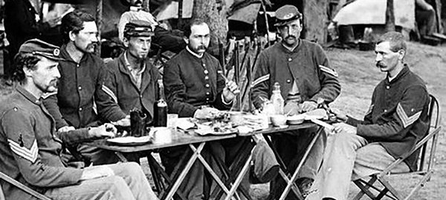**Military history’s four wildest drunken benders led by senior officers**

*By Randall Stevens, We are the Mighty Jan 8, 2026*

***Editor’s Note:*** *Two are from the Civil War. There is some editing for space.*

**1. The guy in charge of ICBMs got too drunk for the Russians in Moscow.**

It takes a lot to be considered “too drunk” in Moscow, but Air Force Maj. Gen. Michael Carey took a trip there in July 2013 and somehow managed to make the Russians look like teetotalers. Commander of 20th Air Force, the operational designation for its land-based Intercontinental Ballistic Missile (ICBM) forces. He was supposed to be in Moscow for a two-day nuclear security exercise, but things went… awry.  
  
People on the trip said he was drunk on an official visit to a monastery, where he tried to fist bump the guide. He allegedly was out late picking up local women, and was said to be drinking excessively in the hotel bar, where he claimed to be “saving the world.”  
  
After he arrived late to the morning meetings, gave a toast at an official lunch, where he made comments about Edward Snowden that “were not well received by his Russian hosts.” Later at dinner he meets two foreign women he knew to be suspicious, but danced with them, got extremely drunk, and tried to convince the restaurant’s cover band to let him play with them. Carey was later fired from his position and retired as a one-star general.

**2. Ulysses S. Grant (may have) drunkenly ridden through Army camps.**

In June 1863, Gen. Ulysses S. Grant was leading the Siege of Vicksburg, the last Confederate stronghold on the Mississippi River, when he ran into journalist Sylvanus Cadwallader. Cadwallader later described meeting Grant as he was steaming on the Yazoo River. Grant was already drunk, but when he boarded the ship, he made a beeline for the bar.  
  
The journalist describes working with Grant’s aides to stop his drinking by confining the general to his wardroom and throwing whiskey bottles out the window. When they docked, Grant reportedly escaped to the shore.   
  
Cadwallader wrote Grant sobered up *briefly*, found more whiskey, got drunk again, and ended up back near Chickasaw Bayou alongside a sutler’s “open bar.” From there, Grant—allegedly on a borrowed horse named Kangaroo—took off through the camps at full speed, scattering fires and causing a full-body panic as everyone tried to keep the Union’s most important general from faceplanting into disaster. Cadwallader said he finally caught him, got him to lie down, and had him hauled back by ambulance. ***Historians cast doubt on the story, though, pointing to other accounts that said sickness confined Grant to his room on the trip.***

**3. A Confederate general got so drunk he could not attack.**

The Battle of Stones River was one of the most significant battles of the Civil War and resulted in the highest percentage of casualties on both sides. A few thousand of those casualties were the result of Maj. Gen. Benjamin F. Cheatham’s drunken escapades.  
  
The rebels had just been pushed out of Kentucky and were fighting to hold Tennessee, while the Union had just issued the Emancipation Proclamation. The stakes were high, but that did not seem to affect Cheatham. He drank to excess and rode his horse, whooping and hollering until he fell off. Not normally a big deal, except that he did it in front of his men while he was supposed to be leading them into battle.  
  
Sober or drunk, Cheatham’s two brigades of irreplaceable veterans were late to the attack and were deployed piecemeal against one of the Union’s best generals, Philip Sheridan. It allowed the Union forces, who should have been on the run, to regroup and re-establish their lines. They later managed a stunning artillery barrage that caused 2,000 - 3,000 casualties in four hours.   
  
The incident was so legendary (notorious) among southerners that Jack Daniel’s later issued a bottle with a portrait of Cheatham on it.

**4. An admiral was fired for wandering a Florida hotel naked.**

Rear Adm. David Baucom the Navy’s top logistics officers, in charge of the Defense Logistics Agency Troop Support, a $14 billion organization that supplies American troops with food, uniforms, and other supplies. He was later promoted to director of Strategy, Policy, Capabilities, and Logistics at the U.S. Transportation Command. Then, he went to Pontevedra Beach, Fla., to attend a National Defense Transportation Association advisory board meeting.  
  
It was there, on April 7, 2015, that he was found wandering around the hotel naked and drunk. Baucom had been drinking heavily the night before, slamming drinks until he could not stand on his own. He reportedly banged his head on a stool, peed his pants, and had to be escorted back to his room. He woke naked and attempted to enter his bathroom, but used the wrong door, leaving the room and becoming trapped outside. Two female hotel guests spotted him looking for a towel to cover up with before a peer got him back to his room.

According to ***ABC News***, Baucom told investigators his prescription heart medications exacerbated his drunken condition. The Navy did not care. He was found to be drunk and disorderly and was removed from his command. He later went to counseling and settled into a job at the Pentagon.

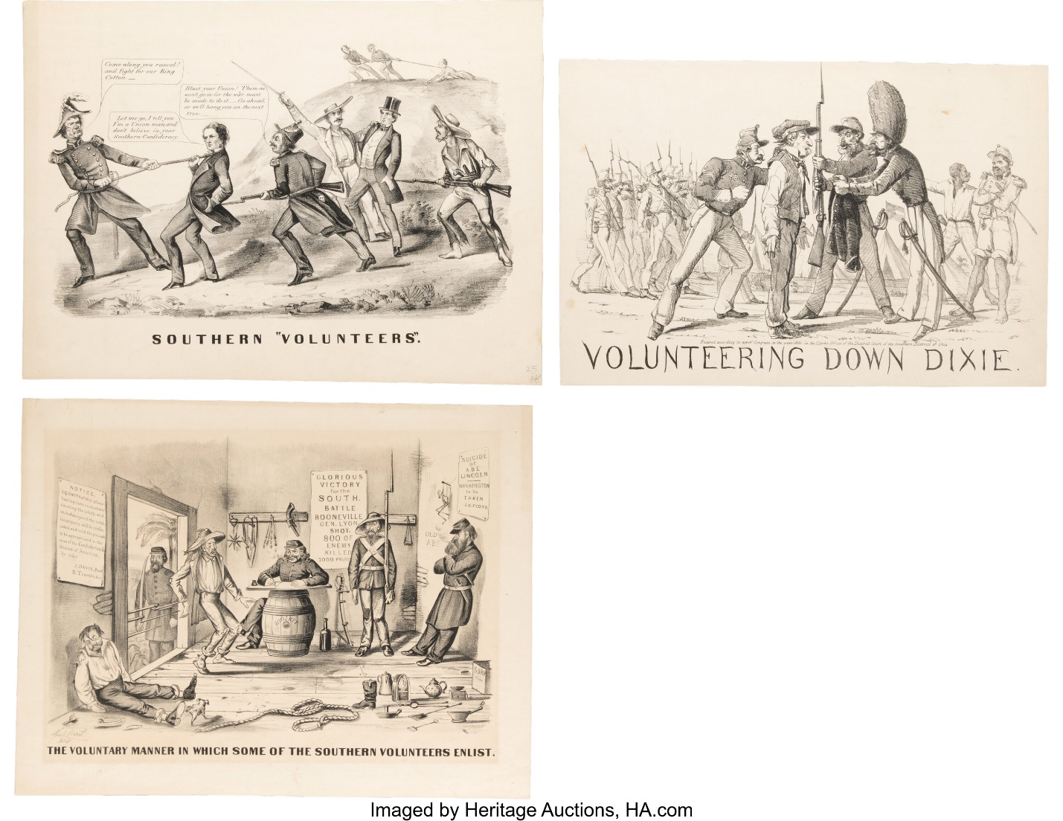**Recruiting 101**

*By Captain Tom Vaselopulos, Recruiting Officer*

***“Enlist now, repent later!”***

To rebuild our unit, we require superior quality people to fill the ranks. To do that everyone is going to have to step up and become a recruiter this year.

The goal of each member should be to try to recruit at least one member to join us in the 2026 reenacting campaign. How do you recruit a new member? This is where you must transform yourself into a “salesman” and make your “pitch” to a potential recruit.

Successful salesmen all have some similar traits:

* **Know your product.**
  + Knowledge about the civil war and the 79th NY Highlanders
  + Your appearance at sutler row – walking billboard
  + Knowledge about the current reenacting event
* **Know your customer.**
  + Must like history if they are at an event.
  + Are they enjoying themselves or having a miserable time?
* **Build rapport and trust.**
  + Greeting them warmly and find out about their interest.
  + Give them a brief history of your experience in reenacting.
  + Gauge their interest in reenacting.
* **Make your “pitch.”**
  + Remember the “pitch” is different for each person, it must be directed for who you are talking to.
  + Have recruiting materials to offer them as you talk to them.
  + If they are genuinely interested offer them the “try before you buy”
  + Invite them to camp, where more members can assist you.
  + In camp let them handle weapons and equipment and try on uniforms and caps.
* **What value does our unit offer?**
  + Being able to fully immerse themselves in history (sleep, eat, march, and fight)
  + Building friendships and comradery for life
  + Family friendly unit
  + Distinct roles they can be involved in
  + Loaner gear, no pressure to buy gear right away.
* **Seal the deal.**
  + Offering them the opportunity to take the field that day
  + Spend the evening or night with us.
  + Review the value again.
  + Be sure to get their contact information and give them yours/or the Recruiting Officers



[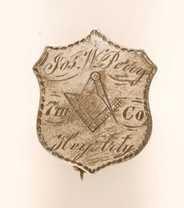](https://nationalheritagemuseum.typepad.com/.a/6a00e550caa66d8834013480364df2970c-popup)

**A Brother in Savannah, Georgia reported this story of Civil War soldiers from his Masonic lodge records.**

It was not long after Fort Sumter, and the War of Northern Aggression was well under way. The Yankees, as they are still wont to do, had promptly flocked to Hilton Head and Tybee Islands, the barrier islands on opposite sides of the mouth of the Savannah River.

The Savannah folks did not mind much that the Yankees had stolen the good beaches, for the water was still a bit cool for Southern preferences and, besides, they knew the gnats and mosquitoes would teach the Yankees a lesson they would never forget. So, the Southerners, as Southerners are wont to do sometimes, just waited.

They did not have to wait long before the Yankees on Hilton Head sent out a messenger under a white flag. It seemed that the Yankees had among them a young fellow who had passed through the Fellow Craft Degree before shipping out. The Yanks were just sitting around slapping gnats when it occurred to one of them that, just maybe, there was a nearby lodge that could test him in the Fellow Craft Degree and raise him to that of a Master Mason.

As luck would have it, there was indeed a lodge in Savannah that would soon be having a Masters Degree. One morning, not too many days later, a detail of Confederate Cavalry slipped across the Savannah River into South Carolina and traveled through Bluffton to the shore opposite Hilton Head Island.

From there they escorted one Fellow Craft Mason and a number of Master Masons of the Northern Persuasion, safely through the Confederate Lines, and back through about thirty-five miles of Confederate defenses to Savannah, where the candidate and his witnesses were delivered into the lodge.

The records note that this Brother was indeed proficient in the Fellow Craft Degree, and he was raised to the Degree of a Master Mason. That night another detail of Confederate Cavalry, no doubt Brothers to a man, slipped back across the Savannah River and safely escorted their Brothers back to Hilton Head.

*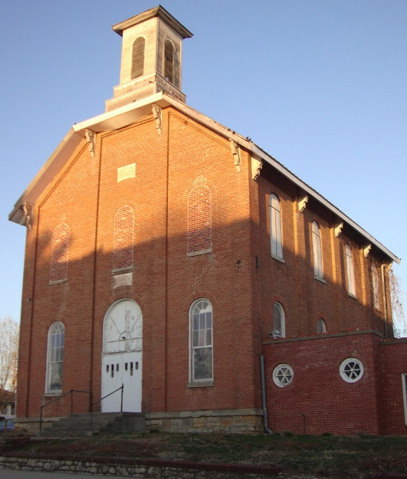Editor’s Note: I have loved this story since the first time I heard it. It clearly demonstrates that, at the darkest period in our Nation’s history, when brothers were killing brothers, Brothers could still be Brothers.*

**Sources:**

*Georgia Masonic Messenger* article by John *Hohenstein, Zerubbabel Lodge No. 15, Savannah, Georgia; reprinted by Southern California Research Lodge in August 2008; published online by Sanford Holst on www.MasonicSourcebook.com, 5 February 2009*.



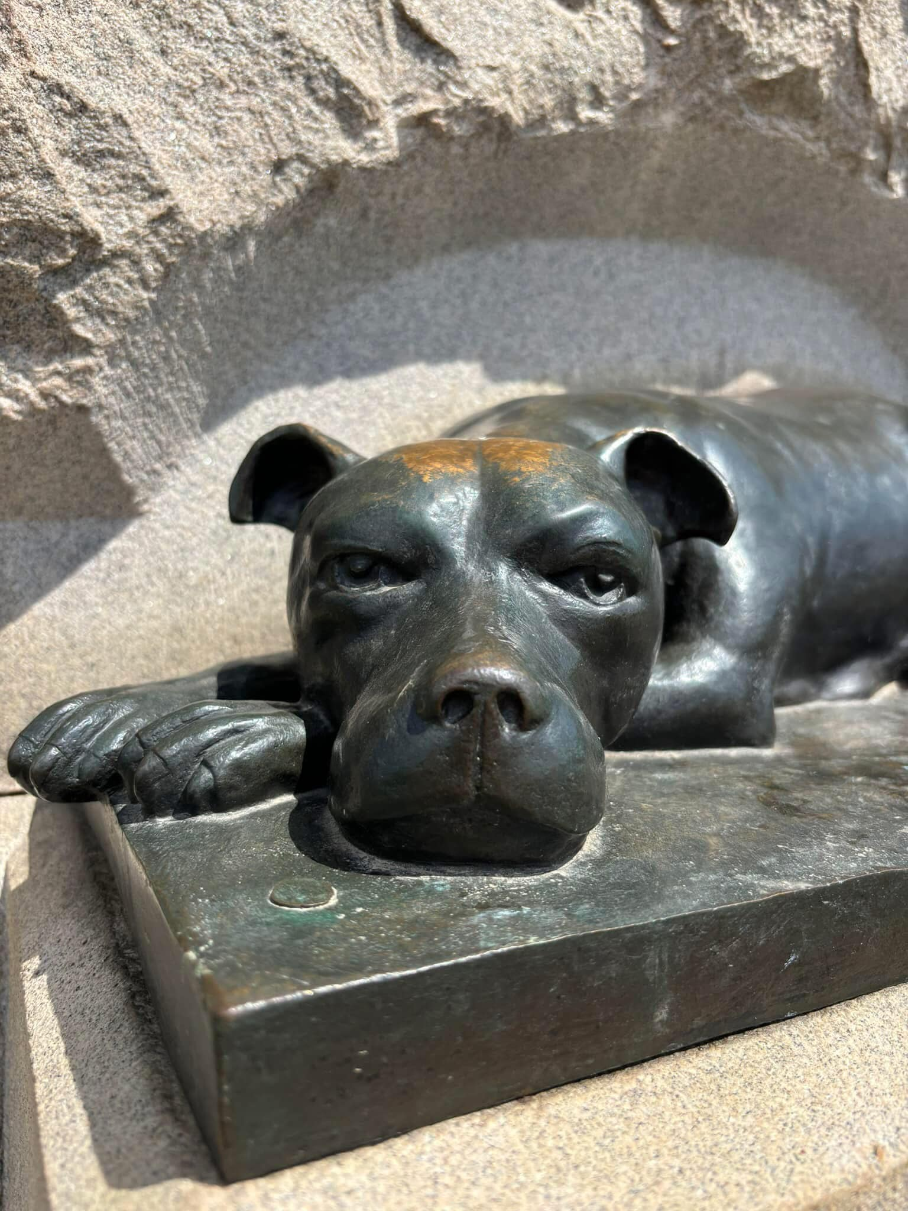*Sallie the dog, keeping watch through eternity over the spirits of her boys, just as she did so many years ago during all the battles they shared. — Monument to the 11th Pennsylvania Infantry, Gettysburg*

·

From an article on the *Hillebrand Rifles Facebook* page

Sallie was not lost — she was watching over the wounded and dead of her regiment...

On the first day of fighting at Gettysburg, 1 July 1863, the 11th PA was driven back from Oak Ridge and into town. During the chaos, Sallie, the regiment’s beloved pug-nosed brindle bull terrier, became lost and separated from her unit.

She was found three days later — Sallie had found her way back to her boys and was now standing guard over the wounded and dead of her regiment. Neither hunger nor thirst swayed Sallie from her duty those hot summer days. Weak from lack of food, her boys nursed her back to health; she served with her regiment for two more years.

Sadly, just two months before the war's end, Sallie was killed at the battle of Hatcher's Run, VA. As the battle raged around them, under “murderous fire” the weeping men of the 11th PA buried their loyal friend and comrade on the field where she fell.

In 1890, when the surviving members of the 11th Pennsylvania Volunteer Infantry erected their monument, they could not forget their little companion who so bravely and so faithfully served by their sides throughout the war. There on Oak Ridge, looking out over the fields in the direction from which the Rebels came, at the base of the statue is a bronze likeness of a little dog. It is Sallie ... keeping watch through eternity over the spirits of her boys, just as she did so many years ago during all the battles they shared. A dog so loyal and so full of love for her boys they insisted she be remembered on their monument, for all time.



**The Trade Blanket**

*Items for sale or trade within our company. If you would like to sell or trade for an item please submit them to the Editor along with a picture, the price and how you should be contacted.*

***No items for sale or trade this month.***



**Checklist Anyone?**

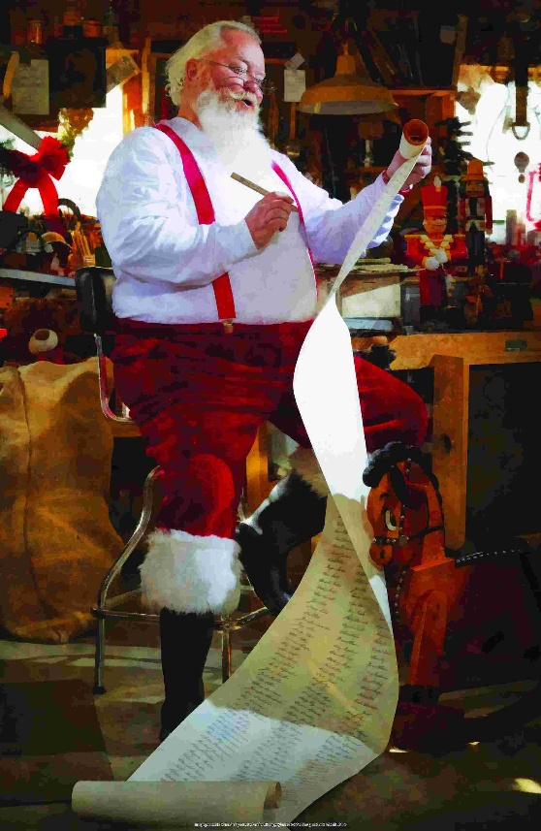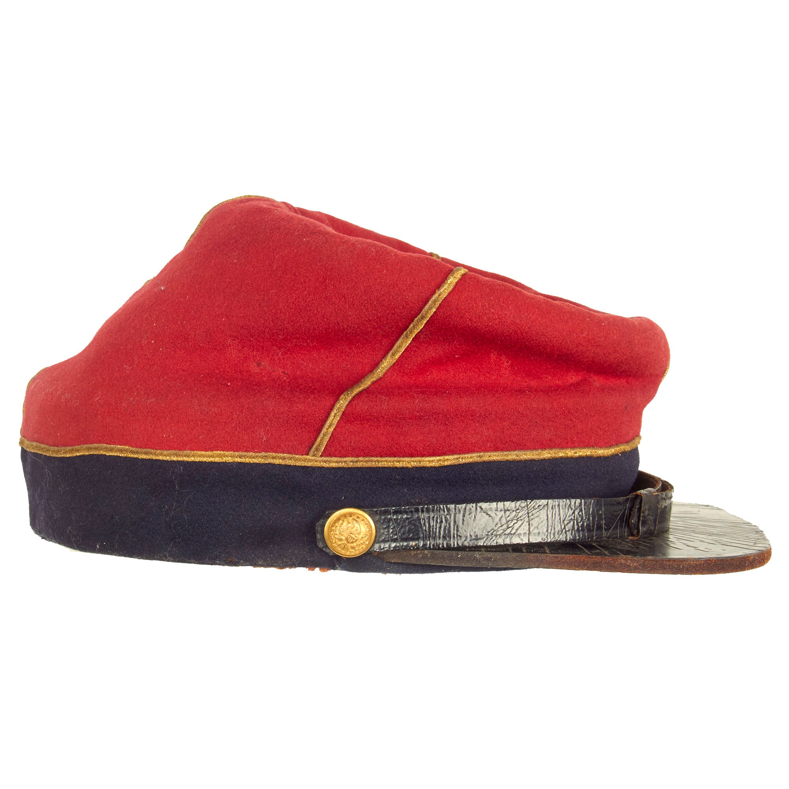

Pilots do it, going on a trip you probably do it, heck even Santa does it. The IT is a checklist and with a reenactment coming up I recommend creating a checklist to help you remember what you should be bringing with you and then actually packing it in your truck. Its also a good time to be checking your rifle and accoutrements to see if they need cleaning or any repairs need to be made. Making your list and checking it twice saves you a lot of aggrevation later!

**Civil War Humor**

